Zeppelin

sqlContext.sql("show tables").toDF().show()

creating dataframe in spark:

https://stackoverflow.com/questions/44901920/create-a-spark-data-frame-from-a-csv-file-which-has-the-headers-in-the-first-row

val department1 = spark.read.option("header","true").option("inferschema","true").csv("/surya/departments.csv")

printing the schema in tree format:

department1.printSchema()

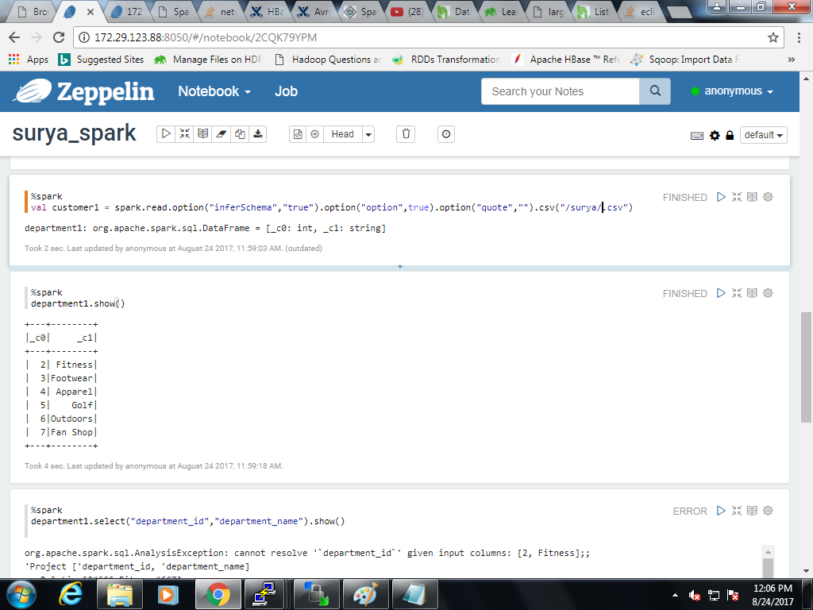

val customer1 = spark.read.option("inferSchema","true").option("option",true).option("quote","").csv("/surya/customer.csv")

customer1.printSchema()



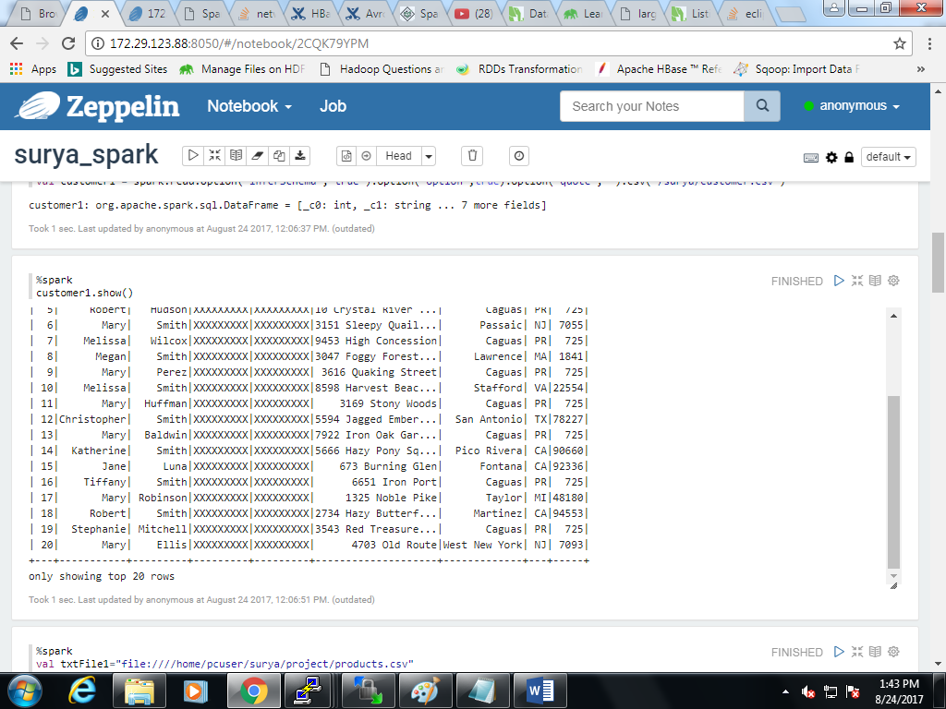

**creating tables in spark and accessing it using sql:**

Customers table:

%spark

val txtFile2="file:///home/pcuser/surya/project/customer.csv"

val txtData=sc.textFile(txtFile2)

txtData.cache()

case class customer100(customer_id:Integer,

customer_fname:String,

customer_lname:String,

customer_email:String,

customer_password:String,

customer_street:String,

customer_city:String,

customer_state:String,

customer_zipcode:String

)

val df= txtData.map {line =>

val s= line.split(",")

val customer_id=s(0).toInt

val customer_fname=s(1)

val customer_lname=s(2)

val customer_email=s(3)

val customer_password=s(4)

val customer_street=s(5)

val customer_city=s(6)

val customer_state=s(7)

val customer_zipcode=s(8)

customer100(customer_id,customer_fname,customer_lname,customer_email,customer_password,customer_street,customer_city,customer_state,customer_zipcode) }.toDF()

df.registerTempTable("customer100")

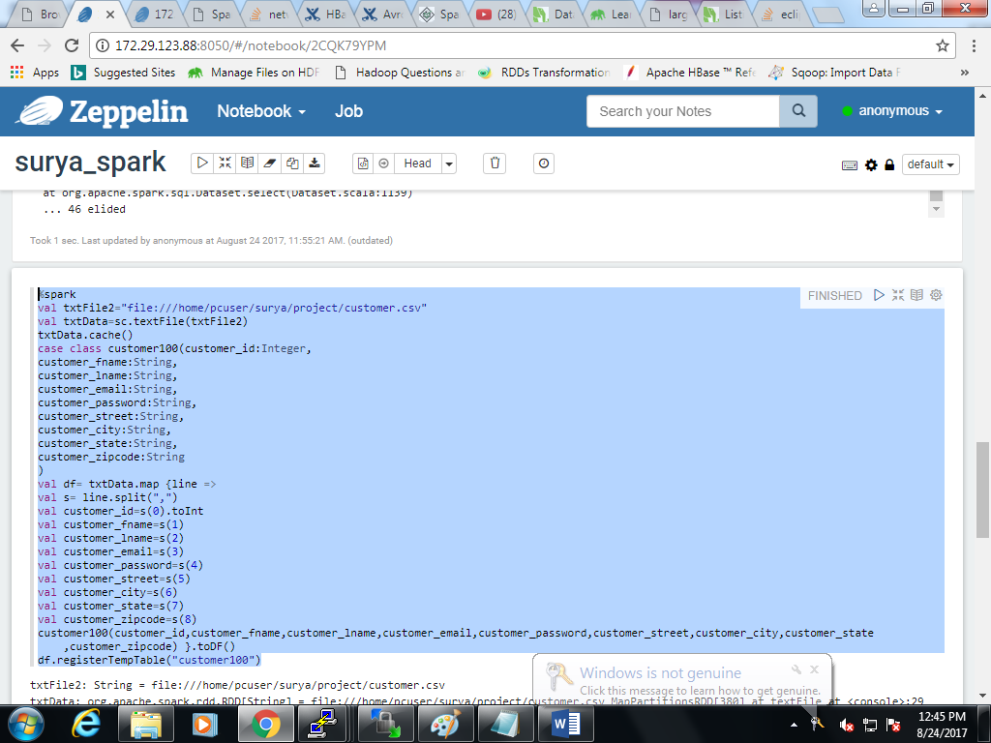

%sql

Select * from customer100

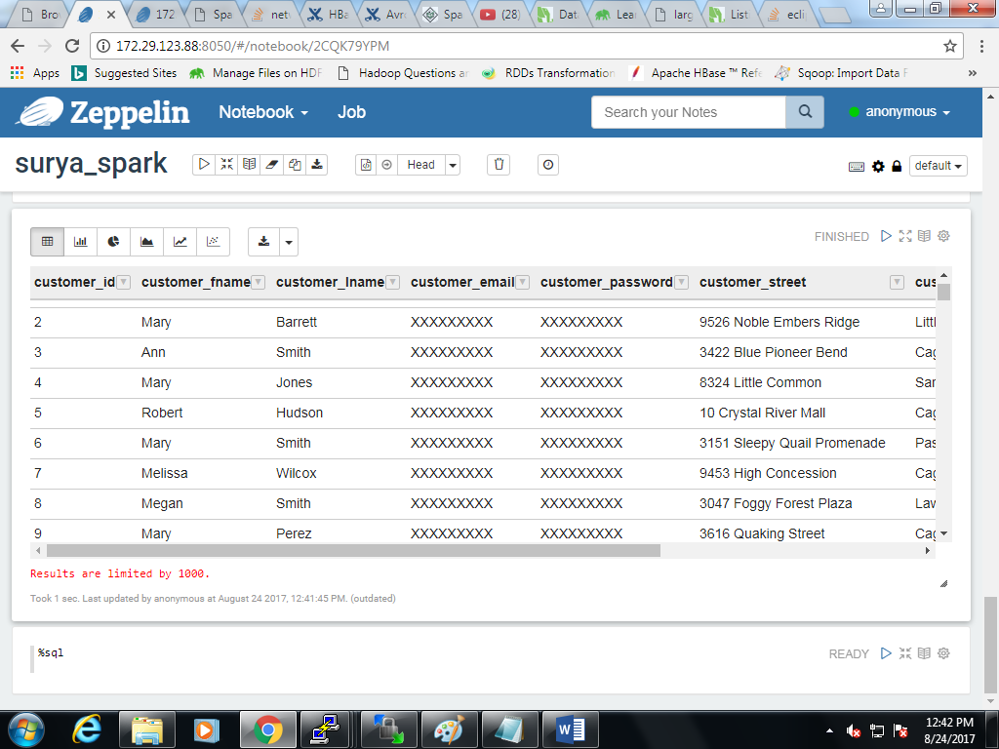

Departments table:

Val txtFile="file:///home/pcuser/surya/project/departments.csv"

val txtData=sc.textFile(txtFile)

txtData.cache()

case class departments(department_id:Integer,department_name:String)

val df= txtData.map {line =>

val s= line.split(",")

val id =s(0).toInt

val name=s(1)

departments(id,name) }.toDF()

df.registerTempTable("departments")

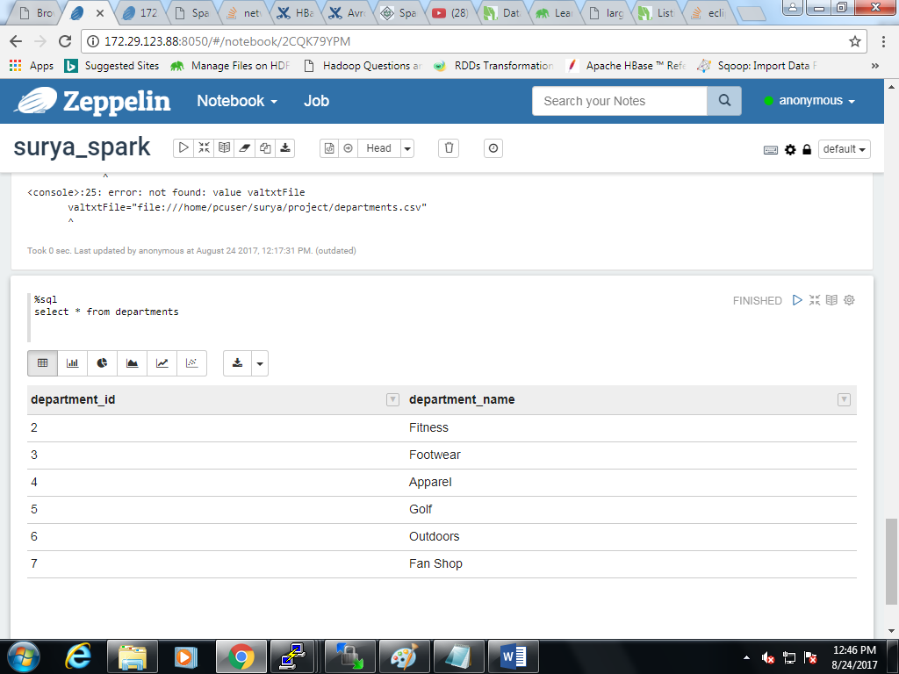

Products table:

%spark

val txtFile1="file:////home/pcuser/surya/project/products.csv"

val txtData1=sc.textFile(txtFile1)

txtData1.cache()

case class products(p_id:Integer,p_cat_id:Integer,p_name:String,p_description:String,p_price:String,p_image:String)

val df=txtData1.map {line =>

val c = line.split(",")

val id = c(0).toInt

val c_id = c(1).toInt

val p_name = c(2)

val p_desc = c(3)

val price = c(4)

val img = c(5)

products(id,c_id,p_name,p_desc,price,img) }.toDF()

df.registerTempTable("products")

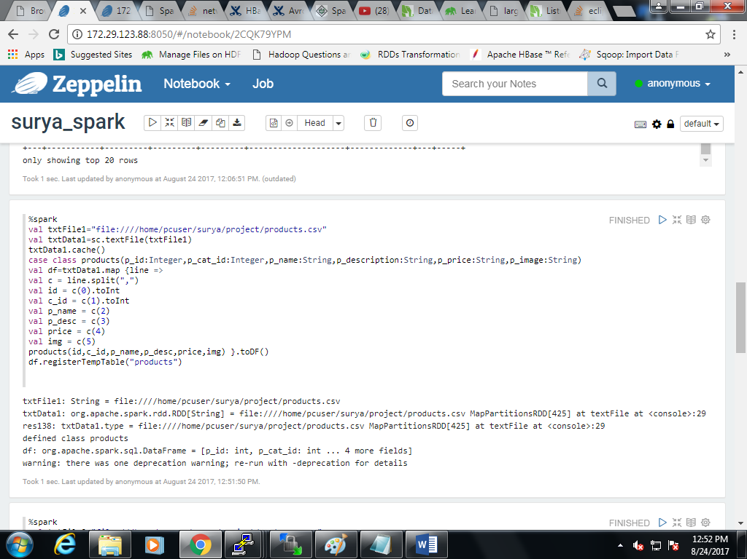

Select * from products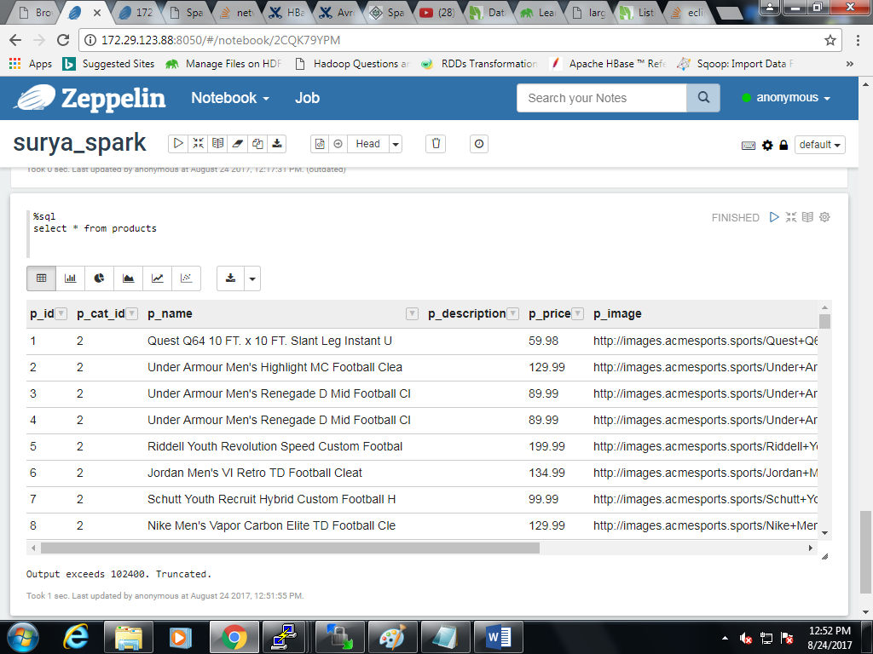

Order_items table:

%spark

val txtFile3="file:///home/pcuser/surya/project/order_items.csv"

val txtData=sc.textFile(txtFile3)

txtData.cache()

case class order_item1 (order_item_id:Integer,

order_item_order_id:Integer,

order_item_product_id:Integer,

order_item_quantity:Integer,

order_item_subtotal:Double,

order_item_product_price:Double

)

val df= txtData.map {line =>

val s= line.split(",")

val order_item_id =s(0).toInt

val order_item_order_id=s(1).toInt

val order_item_product_id=s(2).toInt

val order_item_quantity=s(3).toInt

val order_item_subtotal=s(4).toDouble

val order_item_product_price=s(5).toDouble

order_item1(order_item_id,order_item_order_id,order_item_product_id,order_item_quantity,order_item_subtotal,order_item_product_price) }.toDF()

df.registerTempTable("order_item1")

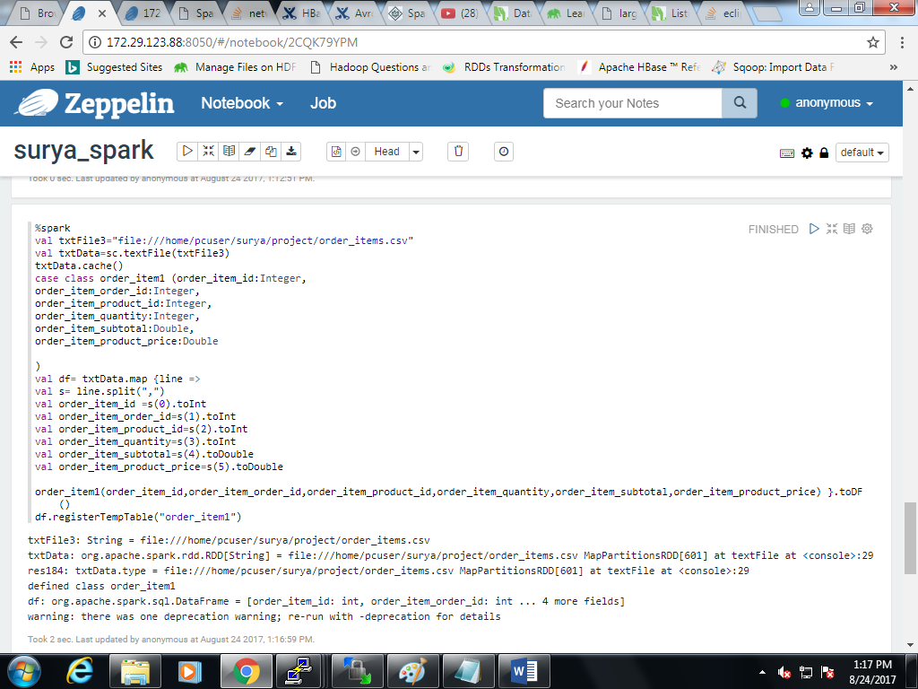

Sql:

Select * from order_item

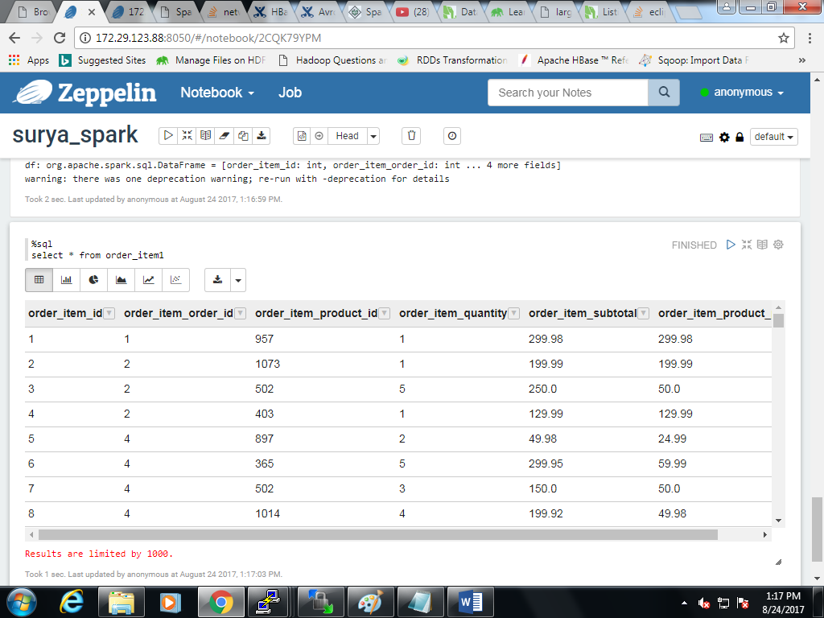

Orders table:

%spark

val txtFile4="file:///home/pcuser/surya/project/orders.csv"

val txtData4=sc.textFile(txtFile4)

txtData4.cache()

case class orderss(o_id:Integer,o_date:String,o_cat_id:Integer,o_status:String)

val df=txtData4.map {line =>

val order= line.split(",")

val o_id= order(0).toInt;

val o_date=order(1)

val o_cat_id=order(2).toInt

val o_status=order(3)

orderss(o_id,o_date,o_cat_id,o_status) }.toDF()

df.registerTempTable("orderss")

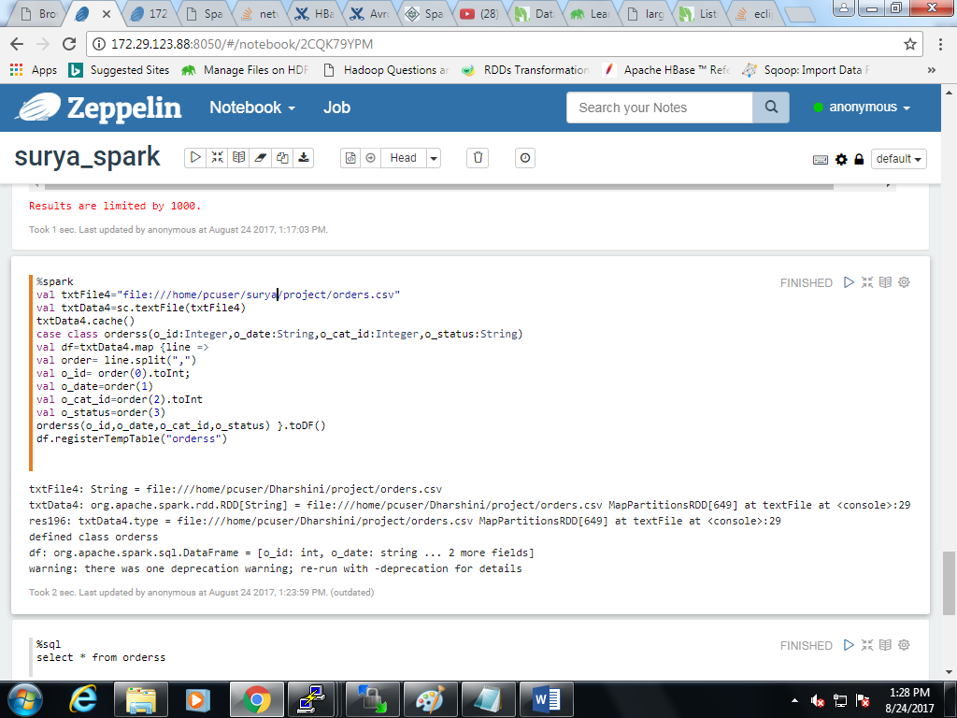

Sql:

Select * from orders

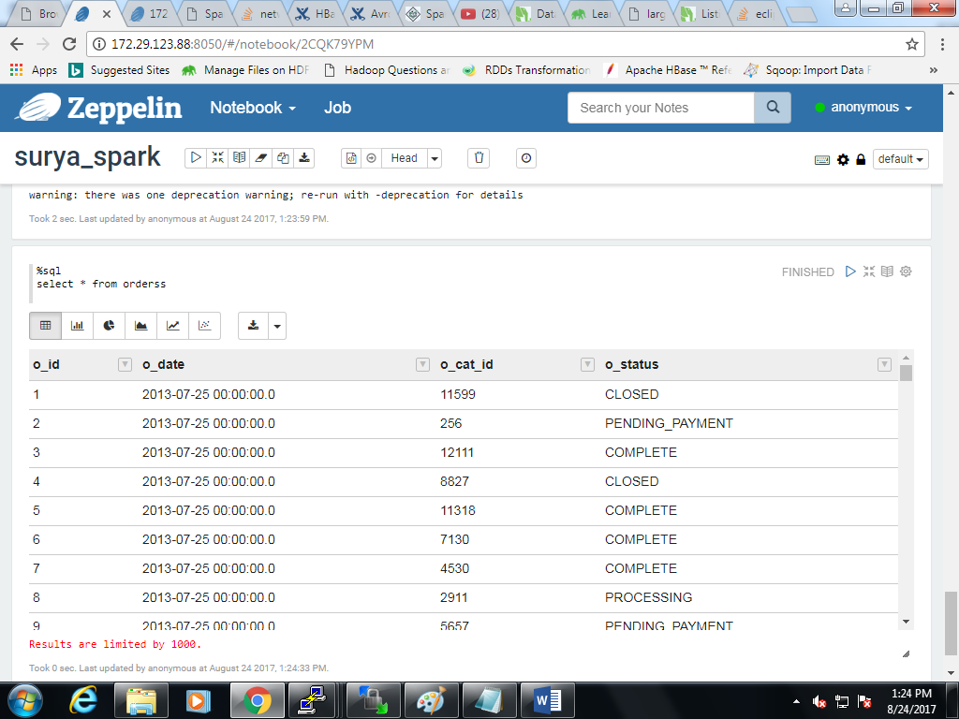

Category table:

%spark

val txtFile6="file:///home/pcuser/surya/project/categories.csv"

val txtData6=sc.textFile(txtFile6)

txtData6.cache()

case class category(

category_id:Integer,

category_department_id:Integer,

category_name:String

)

val df=txtData6.map {line =>

val ca= line.split(",")

val category_id=ca(0).toInt

val category_department_id=ca(1).toInt

val category_name=ca(2)

category(

category_id,

category_department_id,

category_name

) }.toDF()

df.registerTempTable("category")

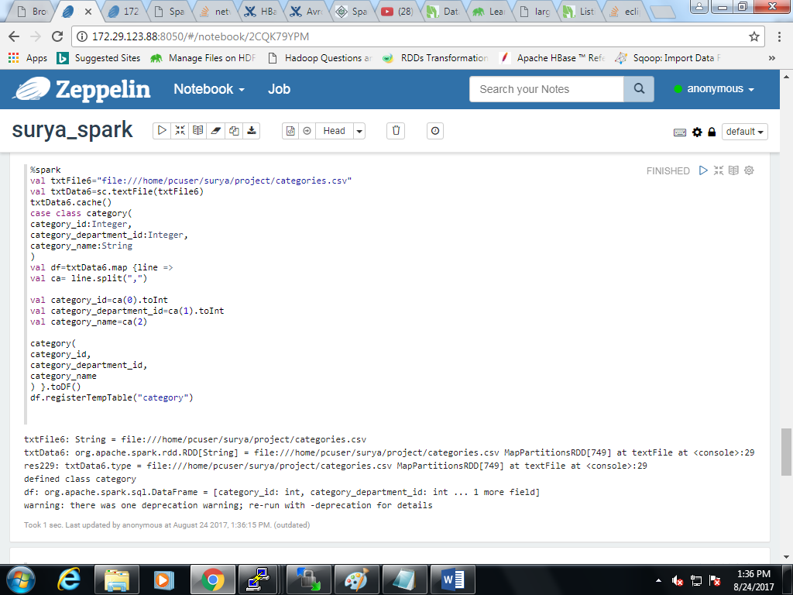

Sql:

Select * from category

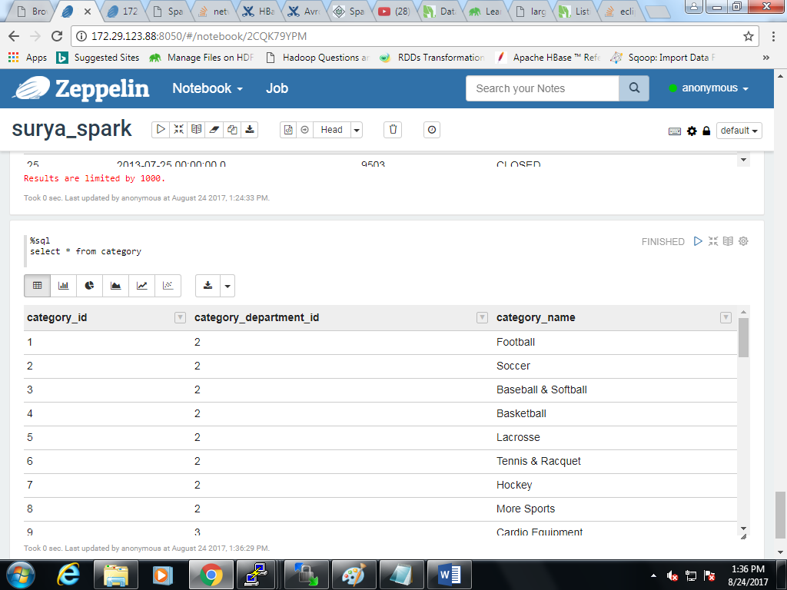

**Joining the tables for queries:**

Create table hnew as (select c.customer_id,c.customer_fname,c.customer_lname,c.customer_email,c.customer_password,c.customer_street,c.customer_city,c.customer_state,c.customer_zipcode,

o.o_date,o.o_id,o.o_status,oi.order_item_quantity,oi.order_item_id,oi.order_item_subtotal,oi.order_item_product_price,p.p_id,p.p_name,p.p_price,p.p_image,p.p_description,ca.category_id,

ca.category_name,d.department_id,d.department_name from order100 o, product100 p, order_item100 oi,customer100 c,department100 d,category100 ca where (o.order_id=oi.order_item_order_id)

and (oi.order_item_product_id=p.p_id) and (c.customer_id=o.o_cat_id) and (p.p_cat_id=ca.category_id) and (ca.category_department_id=d.department_id))

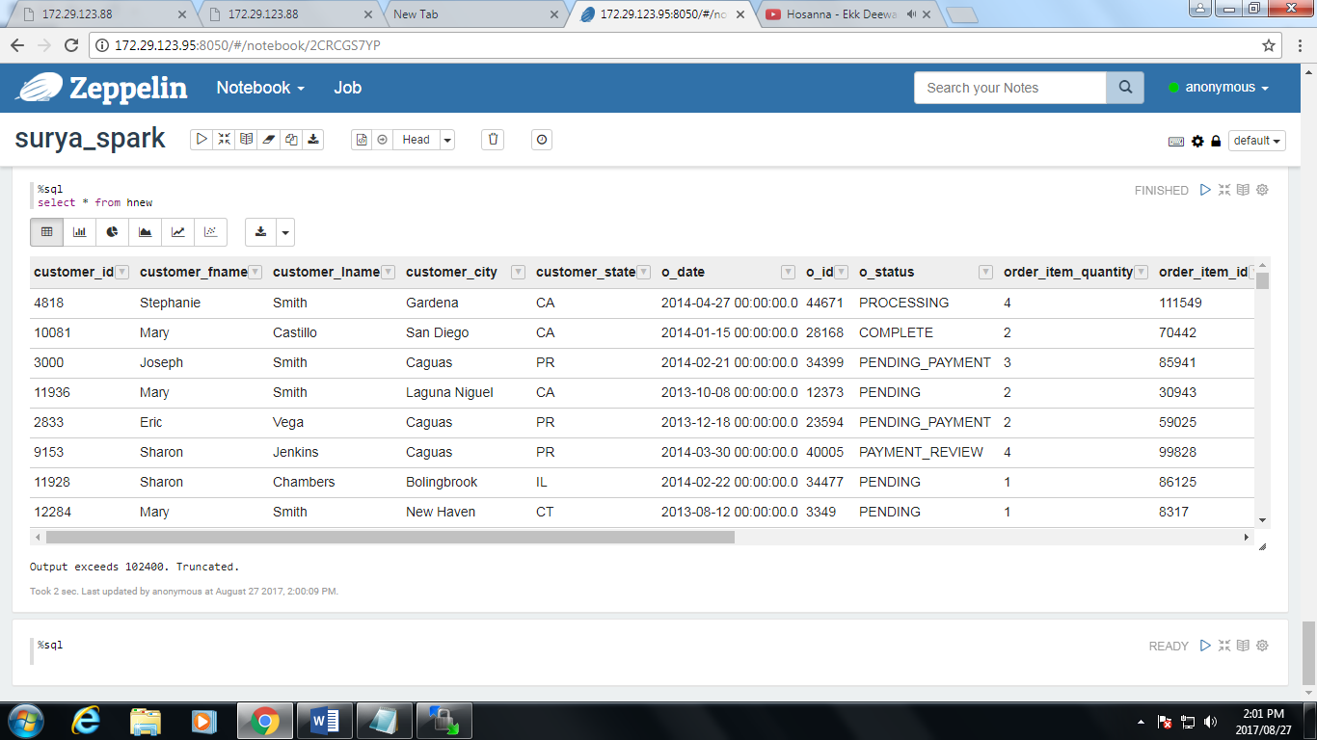

**Top 5 customers:**

%sql

select customer_id,customer_fname,customer_lname,sum(order_item_subtotal) from hnew group by customer_id,customer_fname,customer_lname order by sum(order_item_subtotal) desc limit 5.

based on order_item_subtotal: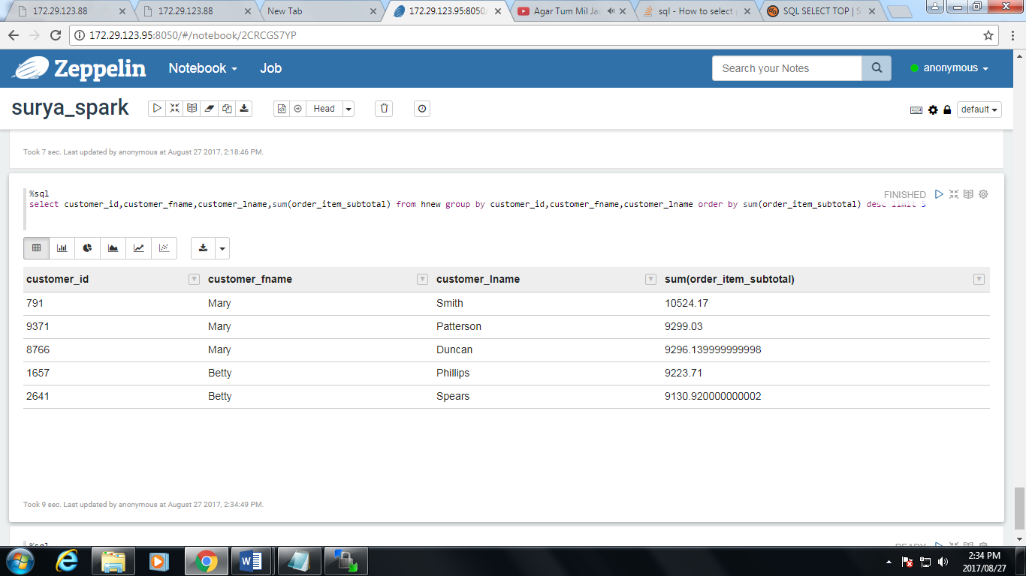

Bar graph:

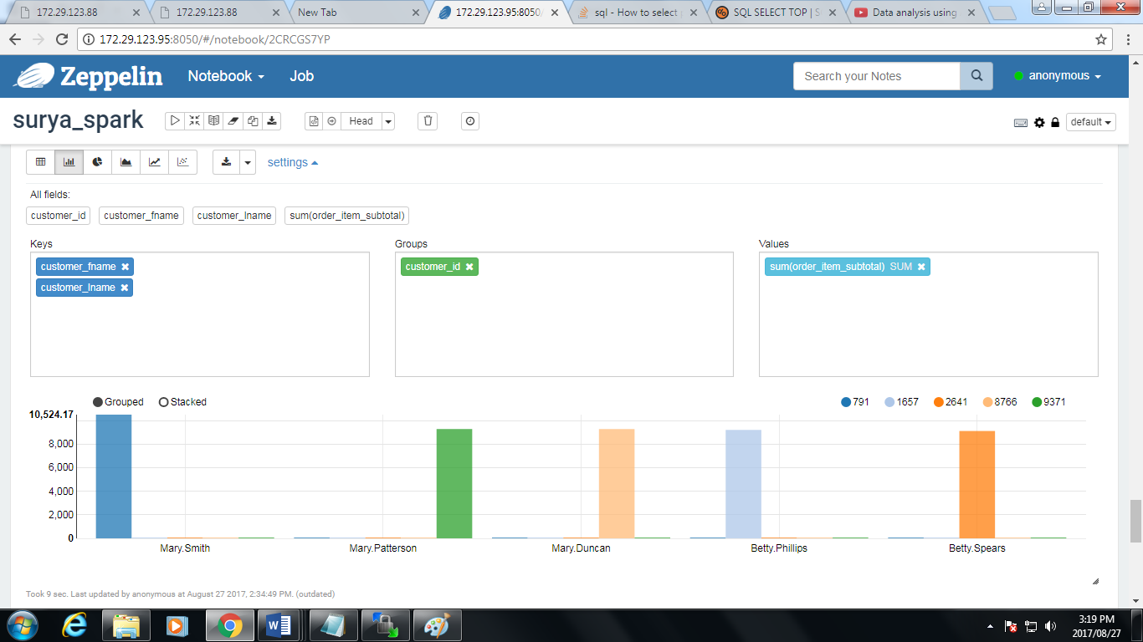

Pie chart:

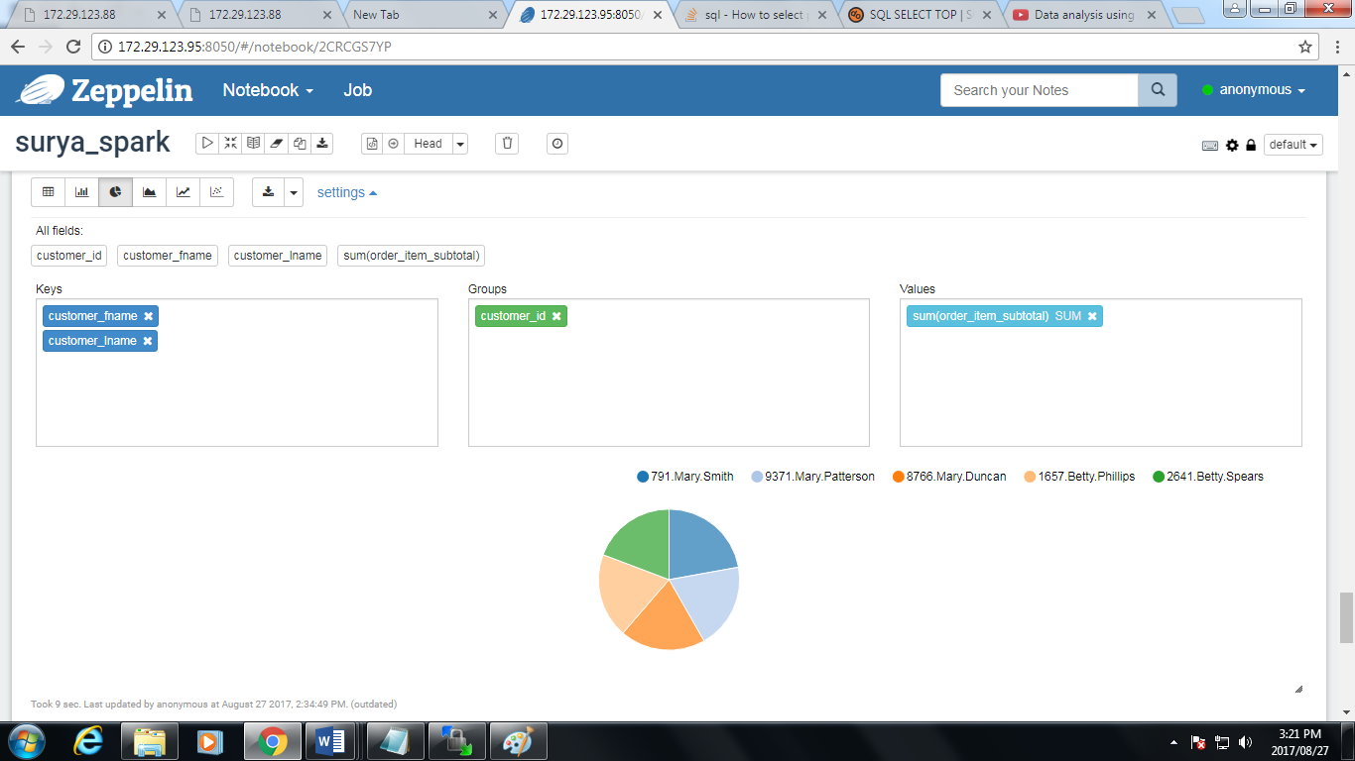

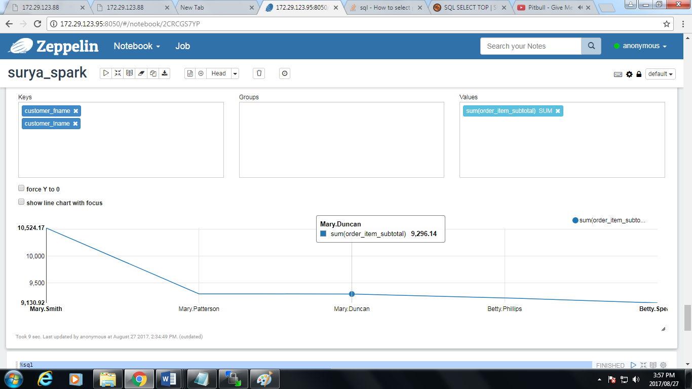

Based on number of orders:

%sql

select distinct(customer_id),customer_fname,customer_lname,count(order_item_quantity) as orders from hnew group by customer_id,customer_fname,customer_lname order by orders desc limit 5

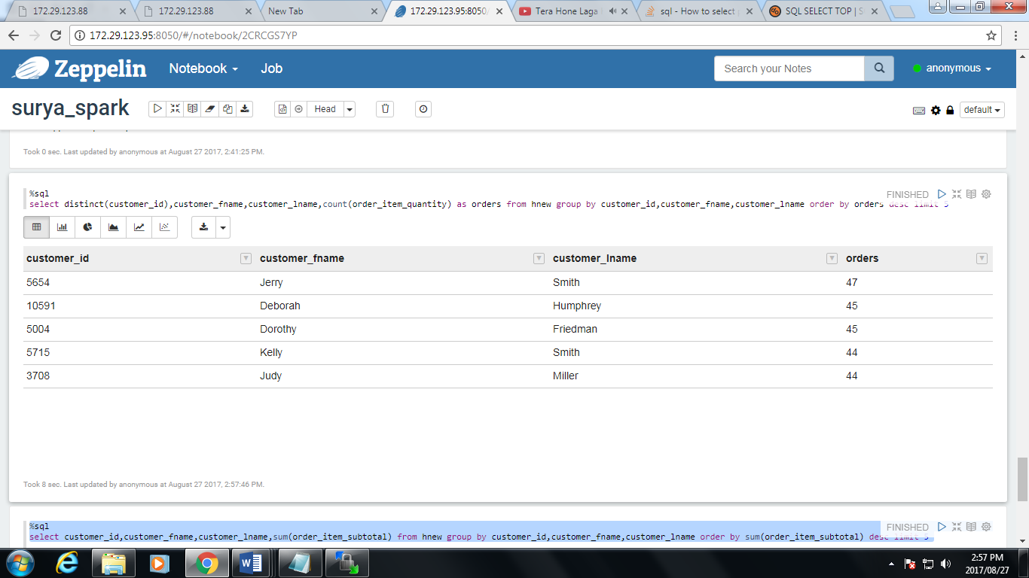

Bar graph:

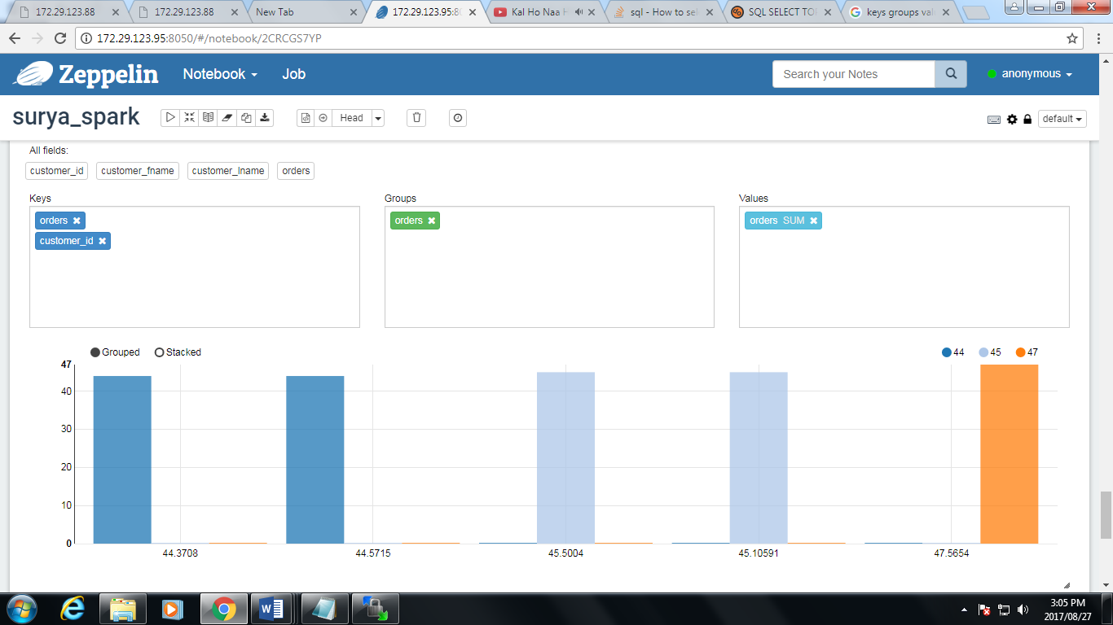

Pie chart:

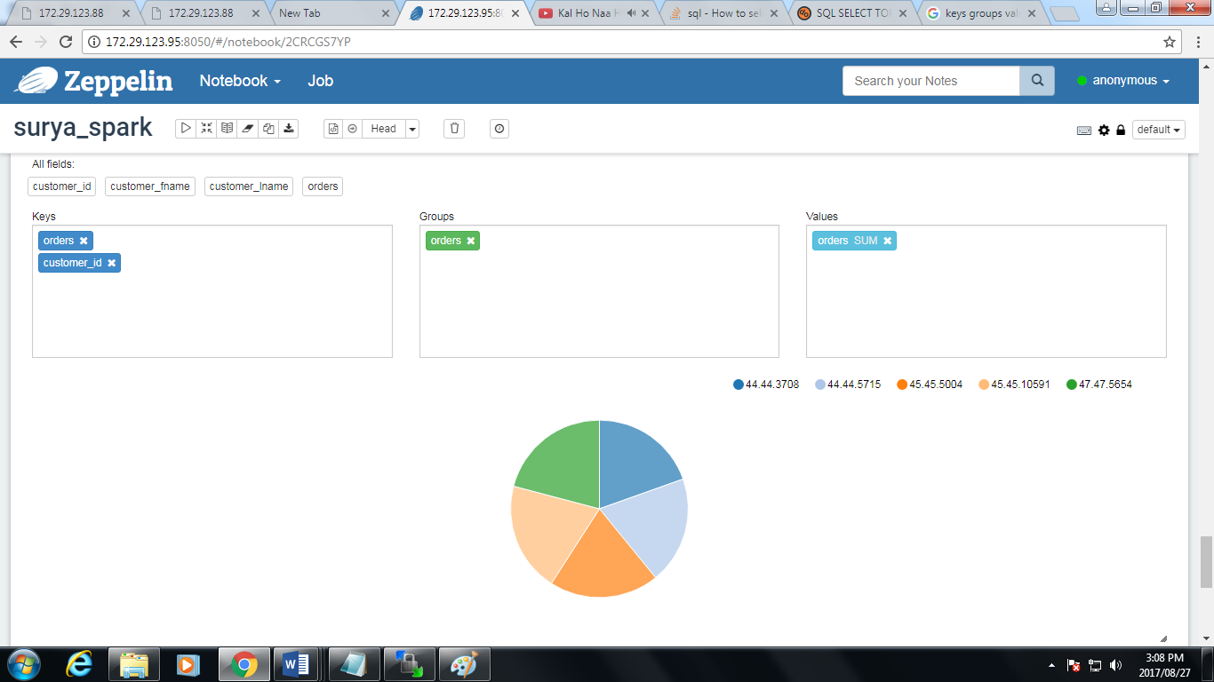

**Top 5 products:**

%sql

select p_price,p_name from product1000 group by p_price,p_name order by p_price desc limit 5

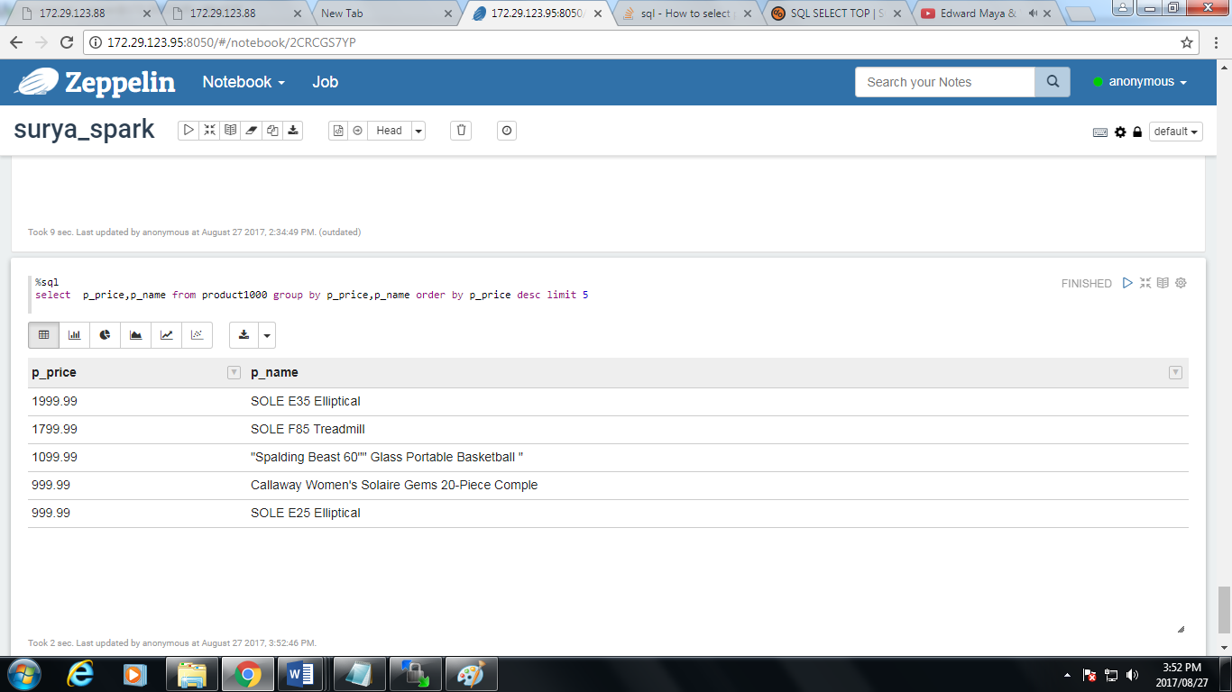

Bar graph:

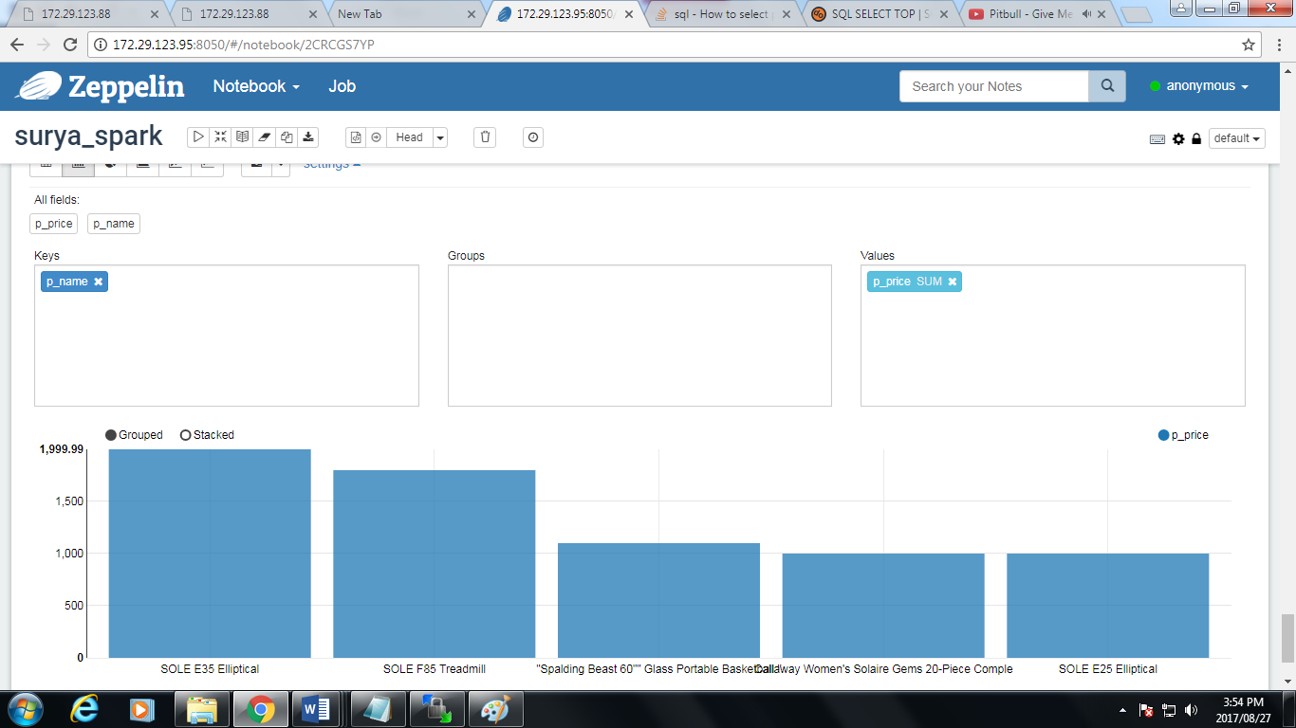

Pie chart:

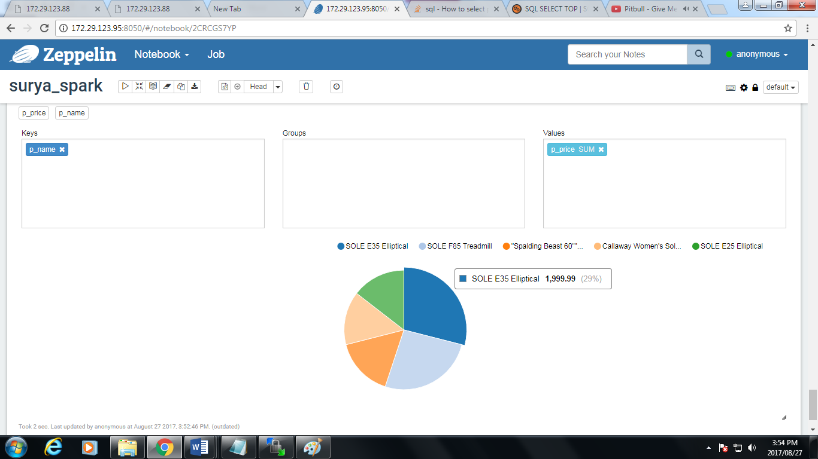

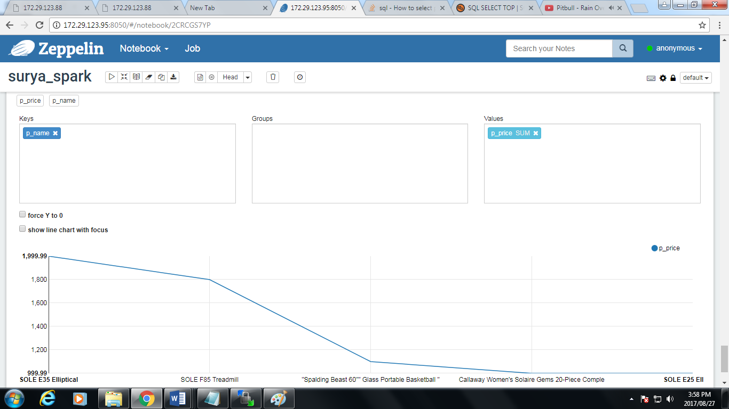

**TOP 5 ORDERS:**

**Based on date:**

%sql

Select p_name,p_price,order_item_quantity,o_date from hnew group by p_name,p_price,order_item_quantity,o_date order by o_date desc limit 5

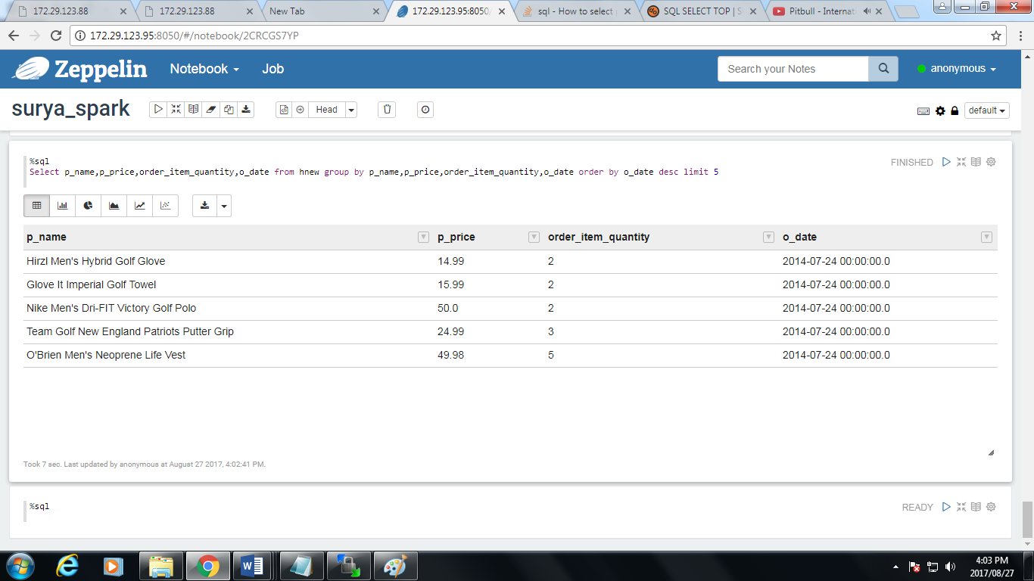

//Latest date from the data.

Bar graph:

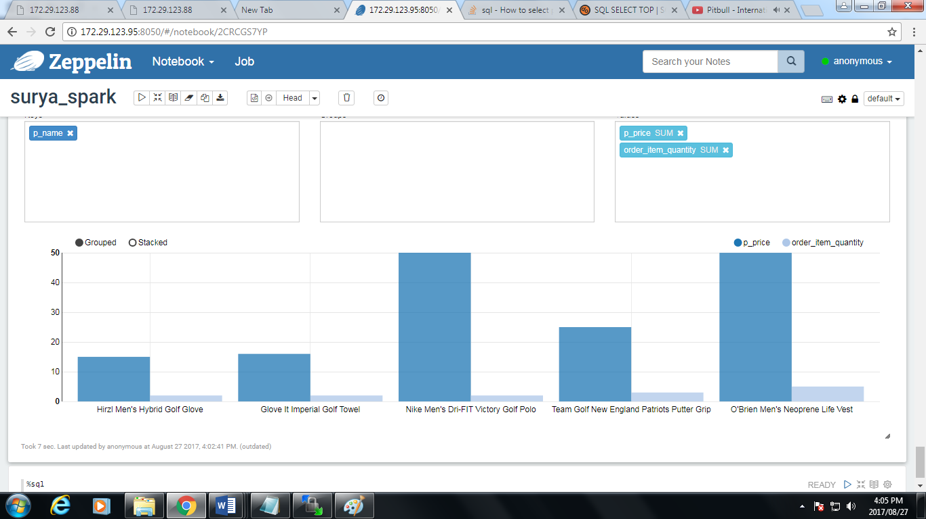

Pie chart: based on price:

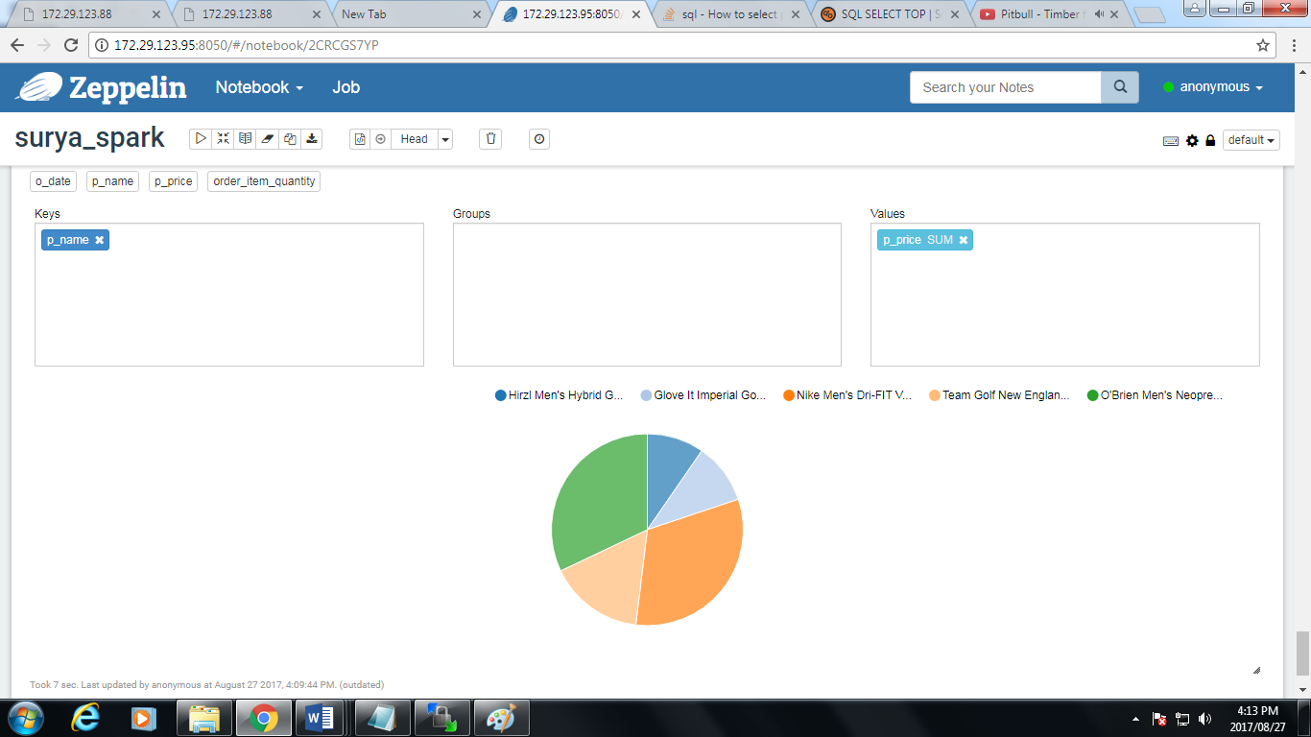based on quantity:

